DESIGN AGENCY

Aim: create an design agency app

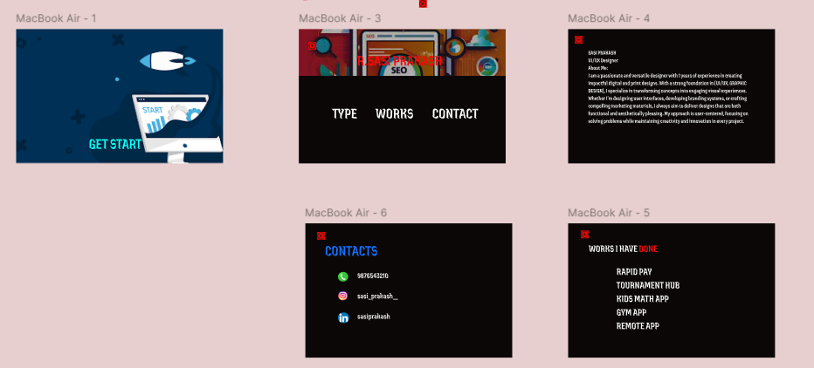

Procedure:

**Step 1: Set Up Your Figma File**

1. **Create a New File**:
   * Open **Figma** and click on **File > New** to create a new design file.
2. **Create Frames (Artboards)**:
   * In Figma, use **Frames** to represent your website screens. For a standard website, you can create frames with dimensions for desktop view (e.g., 1440x1024px or 1920x1080px).
   * Press **F** to create frames.
   * You’ll want to design different pages, so create separate frames for the **Home Page**, **About Us**, **Portfolio**, **Services**, and **Contact** pages.

### **Step 2: Structure the Layout for Key Pages**

We'll start by designing the most important pages of a design agency website.

#### **1. Homepage Design**

The homepage should highlight the agency’s most important elements: brand, services, and portfolio.

* **Hero Section**:
  + **Large Image or Video Background**: Use a high-quality hero image or a video of your design work. This could also be a full-width image slider.
  + **Agency Branding**: Include the **agency’s logo** and tagline over the hero image.
  + **Call to Action (CTA)**: Use a prominent button like **“Start a Project”**, **“Get in Touch”**, or **“See Our Work”**.
  + **Navigation**: Include a sticky navigation bar at the top with links to **Home**, **About**, **Portfolio**, **Services**, and **Contact**. It should be clear and easy to use.
  + **Visual Hierarchy**: Use large, bold typography for your headline (e.g., **“We Create Beautiful Digital Experiences”**), with a smaller subheading that explains your work.
* **About Section**:
  + **Short Description**: Add a brief section below the hero that introduces your agency. Keep it concise and to the point (e.g., "We’re a creative agency specializing in UI/UX design and branding").
  + **Mission or Philosophy**: Add a short paragraph explaining your agency's vision or design philosophy.
  + **Team Photos**: Showcase your team’s photos or creative portraits (optional).
* **Services Section**:
  + Create cards or tiles that display your **core services** (e.g., **Branding**, **UI/UX Design**, **Web Development**, **Motion Design**).
  + Each service card can have an **icon** or image that represents the service, along with a short description and a **Learn More** link or button.
* **Portfolio Section**:
  + Display a **grid or carousel** of your best work (projects, case studies, etc.).
  + Each project could be represented with a thumbnail and short description. Include a **“View Project”** button for each.
  + Make the design visually appealing by using large images or interactive hover effects.
* **Client Testimonials**:
  + Show **client logos** or quotes from satisfied customers to build trust. This could be a horizontal carousel or grid.
  + Use simple text and client photos to humanize the feedback.
* **Footer**:
  + Include essential information like **contact details**, **social media links**, **terms of service**, and **privacy policy** in the footer.
  + Optionally, add a **newsletter subscription form**.

#### **2. About Page Design**

The **About Us** page is where you will explain the agency’s story, mission, values, and showcase the team.

* **Hero Image**: Include an image that reflects the agency’s personality. A team photo or a creative, abstract design could work well.
* **Agency Story**:
  + Create sections that describe your agency’s history, mission, and goals.
  + Use **clear headings** and **paragraph text** to explain who you are and what sets you apart.
* **Team Section**:
  + Display the **team members** with photos, names, titles, and short bios.
  + Consider using **interactive hover effects** or **sliders** to make the section more engaging.
* **Values and Philosophy**:
  + Include a section about your **values** (e.g., creativity, collaboration, innovation).
  + Use a list or icons to represent each value clearly.

#### **3. Portfolio Page Design**

The **Portfolio** page will showcase your best design work, emphasizing your creativity and skill.

* **Project Thumbnails**: Create a **grid of projects** with thumbnails for each project. When a user clicks on a thumbnail, it should take them to a detailed case study page.
* **Filters**: Add filters at the top to allow users to browse by project type (e.g., Branding, Web Design, Mobile Design, etc.).
* **Hover Effects**: Use hover effects on the project thumbnails that show more details (e.g., a project title or short description).
* **Project Details**: Each project page should include:
  + A large **hero image** of the project
  + **Description** of the project, the problem you solved, and the process
  + **Screenshots** or visual examples of the work (UI/UX screens, logos, etc.)
  + Optionally, include a **testimonial** or feedback from the client.

#### **4. Services Page Design**

The **Services** page will explain in detail what the agency offers. It’s important to present services clearly so potential clients understand how you can help them.

* **Service Categories**:
  + List your services with icons, images, and short descriptions. For example, **Branding**, **UX/UI Design**, **Web Development**, etc.
  + Use a clean grid or **card-style layout** for easy navigation.
* **Detailed Descriptions**: Under each service, provide more detailed information about what’s included, the process, and why clients should choose you.
* **CTA**: At the end of the page, include a strong **Call to Action** such as “Ready to start your project?” or “Let’s Talk”.

#### **5. Contact Page Design**

The **Contact** page is crucial for converting visitors into leads. This page should make it easy for users to get in touch.

* **Contact Form**: Include a simple form that asks for **Name**, **Email**, **Message**, and a **Submit Button**.
  + Use clear labels for each field and ensure the form is easy to fill out.
* **Location**: If relevant, include a map to show your office location. This can be done using an embedded Google Maps widget.
* **Contact Info**: Include alternative contact information like **email**, **phone number**, and **social media links**.
* **Social Media Links**: Ensure that social media buttons are easily visible and linked to your profiles (e.g., Instagram, Dribbble, Behance).

### **Step 3: Visual Design**

#### **1. Color Scheme**

* Choose a **brand color palette** that reflects the agency’s personality. For a design agency, you can go for bold, modern colors with a touch of sophistication.
* Typically, design agencies use neutral colors (whites, blacks, grays) combined with one or two vibrant accent colors (e.g., blue, orange, green).

#### **2. Typography**

* Use modern, readable fonts. Popular fonts for design agencies are:
  + **Headers**: Serif or bold sans-serif fonts like **Montserrat**, **Poppins**, or **Playfair Display**.
  + **Body**: Clean sans-serif fonts like **Roboto**, **Lato**, or **Open Sans**.
* Ensure **font hierarchy** (size, weight, and color) is consistent for readability and to guide the user’s attention.

#### **3. Icons and Imagery**

* Use **simple, clean icons** for services, contact options, and navigation. Figma has plugins like **Feather Icons** or **Material Icons** for this.
* For images, use high-quality visuals. You can use stock photos or create custom illustrations or mockups that align with your agency's style.
* **Illustrations**: If your agency has a creative style, adding custom illustrations can make the design stand out.

#### **4. Spacing and Alignment**

* Keep plenty of **white space** around elements to ensure the design doesn’t feel cramped.
* Use **grid systems** and alignment tools in Figma (e.g., Auto Layout) to keep everything neat and consistent.

### **Step 4: Prototype and Interactive Design**

* **Prototyping**: Use **Figma's Prototyping feature** to create clickable prototypes of your design. You can link buttons to navigate between pages, hover interactions for elements like images, and transition effects.
* **Testing**: Use **Figma's Presentation mode** to interact with the prototype and test the flow of your design.

### **Step 5: Export and Handoff**

* **Export Screens**: Once your design is complete, export your screens in appropriate formats (PNG, JPG, or PDF).
  + Select the frames (screens) you want to export and click on **File > Export**.
* **Handoff to Developers**: Share the design with your development team via Figma's **Share** link. Developers can inspect elements, view measurements, and get asset details directly from the file.

Result:

Successfully created design agency.